
Serials Manual
  - For Version 7 with Scribe Duplication

Keystone Systems, Inc.
8016 Glenwood Ave., Suite 200
Raleigh, NC 27612
800-222-9711
ks7@klas.com

Contents
Navigating the Serials Module 2
Holding and Inventory records 2
Navigation Tips 3
Serials Circulation 4
Add a new Issue 4
Upload a file for Duplication 6
Seed Serial 7
Reserve a Specific Issue 7
Print Serial Mail Cards 8
Generate Email Distribution List 9
Troubleshooting Serials 10
Serials Maintenance 11
Add a new Serial 11
Add a Serial Caption 12
Add or Update Holding and Retention 14
Change a Serial’s Medium 15
Withdraw an Issue 16
Withdraw a Serial 17
Resume a Serial 18
Cancel Subscribers 19
Resume a Subscription 19
Standard Functions & Terms 20
Serial Terminology 20
Understanding Retention 20
The Toolbar 21
Browse Tables 22

Navigating the Serials Module
The Serials Module includes a Header with key information about the currently selected Serial Record, a tree menu on the left of the screen, and the record itself on the right.
- If you know the Serial KLAS ID of the desired record, select it in the tree view.
- OR, use Find (Ctrl-f) to open a record by Title, Item Barcode, or ISSN.
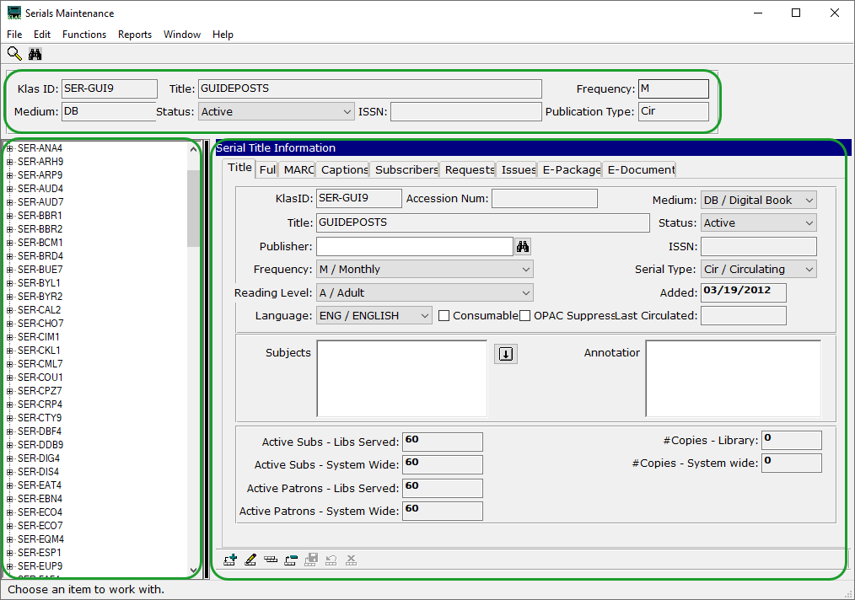

Holding and Inventory records
Use the plus sign to the left of the Serial KLAS ID in the tree view to access the Holding records for that serial (UCSC - MagShelf - 1 in the example below). For physical serials, the inventory records will be under the corresponding holding at level three (Copy View or Issue View).
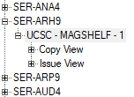
Either Copy View or Issue View can be expanded using the plus sign to navigate physical inventory records by copy number or by issue name.
Note: No inventory records are generated for Duplication on Demand serials, but the Holding is used to apply Retention and other settings.

Navigation Tips
Unlike elsewhere in KLAS, Serial records cannot be refreshed using F5. If you need to reload a screen to view potential changes (such as checking for new Requests after using Seed Serial), select a different Serial record in the tree view, then return to the record in question.
To switch between the header / tree view and the current record using a keyboard, press F6.

Key Tabs Guide:
- Title (Alt-1) - Basic information about the serial as a whole. See page 11.
- Captions (Alt-4) - New Issue Names are generated based on the Caption. See page 12.
- Subscribers (Alt-5) - All patrons with a Subscription record for this Serial. Use the filter to view only Active subscribers. Seed Serial can be used here; see page 7.
- Requests (Alt-6) - Serial Reserves can be reviewed here. To remove old Reserves and create new Reserves the Retained issues, use Seed Serial on the Subscribers tab.
- Issues (Alt-7) - A listing of all Issues for the serial, from oldest to newest. See page 4.
- E-Document (Alt-9) - A listing of all files known to match this serial. See page 6.

Serials-specific Functions:
- Receive Issue (Functions Menu) – Includes option to add holding. See pages 5, 14.
- Seed Serial (Ctrl-Y) - Only available on the Subscribers tab, Alt-5. See page 7.
- Service Subscription (Ctrl-U) - Only available on the Subscribers tab, Alt-5. See page 7.

Serials Circulation

Add a new Issue
For NLS serials (MoCs), the new Issue will be generated automatically when the new file is available. For local serials, however, each Issue must be added when you are ready for it to start circulating.

Add an Issue for duplication
- Go to the Issues tab (Alt-7) of the Serial Record.
- Use the Add Record button to create the new Issue (Ctrl-n).
- Use the combo-boxes to select the appropriate chronology information. The issue name will be generated according to the information entered and the serial’s Caption Pattern. For more information on Captions, see page 12.
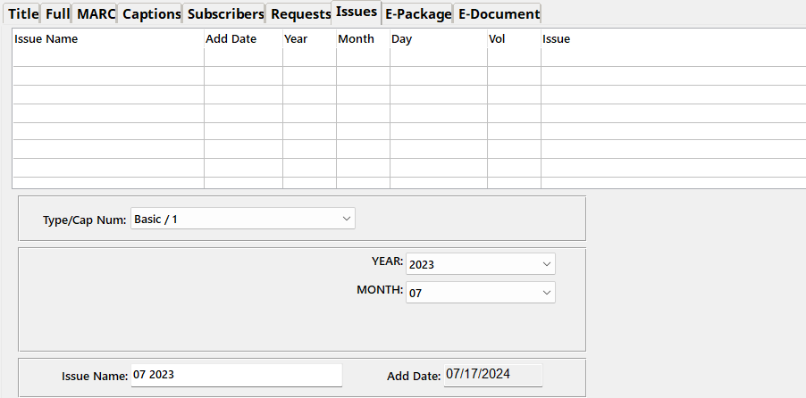
- Save the new Issue. (Ctrl-s)
The new Issue will be listed on the Issues tab and subscribers that have already had the previous Issue will automatically receive a Serial Reserve for the new Issue.
You will need to Upload a file for Duplication (see page 6), and you may want to Seed Serial (see page 7) to remove any unfilled Reserves for previous issues.

Receive a Physical Issue
  - Use the Functions menu to select Receive Issue.
  - On the Serials Receive screen, enter the KLAS ID of the serial, or use the Lookup button to find it. The Title for the current KLAS ID will be displayed.
  - Select the Holding, or use the Add Holding button to create one.
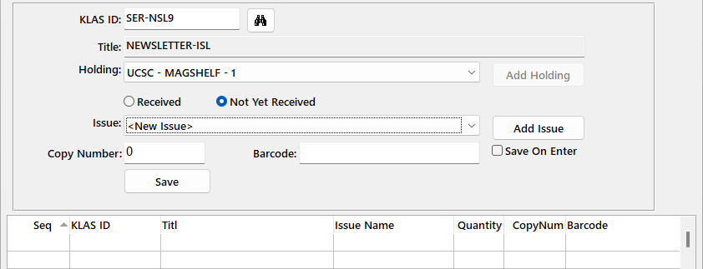
  - If the Issue already exists and you are simply adding new copies, change the radio button to Received. Select the Issue from the drop-down.
Otherwise, leave it on Not Yet Received, then use the Add Issue button.
    - Select the appropriate chronology information in the combo-boxes. The issue name will be generated according to the information entered and the serial’s Caption Pattern. See page 12 for more information.
    - Save (Ctrl-s) the new Issue. The Issue record will be created, and Subscribers that have already had the previous Issue will automatically receive a Serial Reserve for the new Issue.
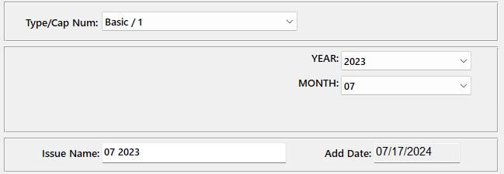
KLAS will return to the Receive screen with the new Issue selected.
  - For copy-specific serials: mark Save on Enter checkbox, then place your cursor in the Barcode field. Scan the barcode for each Copy.
For non-copy-specific serials: enter the total number of Copies, then Save.
The added copies will be displayed in the browse table at the bottom of the screen.

Upload a file for Duplication
The Serial Issue should be formatted as a DTB (Digital Talking Book), and placed in a .zip compressed folder.

Serial Issue filename
KLAS will automatically generate an eDoc linking the recording file to the Serial Issue record, but to do so, the file name must match according to its internal logic.
For simplicity, it is best not to use spaces in your Issue names, but if you do, they should be replaced with underscores for the file name.
- An issue name of “JAN 2023” matches “JAN_2023.zip"
- An issue name of “Jan-Feb 2023” matches “Jan-Feb_2023.zip”
When naming the files for new issues, make sure that you are consistent and follow the serial’s Caption Pattern. See page 12 for more information and recommendations.
Be very careful to stay on pattern. A human can tell that “2024-07” and “2024-7” are the same thing, but KLAS can’t!

Upload the file to books.klas.com
Upload the file to the standard books.klas.com file storage:
- Use your FTP Client to connect to books.klas.com (contact Customer Support for specific instructions and the password for your library).
- Select the “public,” “private,” or “shelf” directory as desired.
  - The Public directory is for files that can be downloaded by non-authenticated users.
  - The Private directory is for files that should only be downloaded by logged-in users.
  - The Shelf directory is for files to be shared with other libraries via the SHELF project.
Note: Regardless of directory, your serials are only displayed on the WebOPAC at your request.
- Place the file in a folder matching the KLAS ID.
  - Example file path: public/SER-NWL9/
Overnight, KLAS automatically matches up files to records; as part of this process, it will add an eDoc to the new Serial Issue added in the previous section.

Seed Serial
When a new Issue is added, KLAS automatically creates a Serial Reserve for all subscribers who have already received the previous issue. However, no Reserve is created for those who still have an outstanding Reserve for a previous issue.
With many serials, it is preferred to remove the previous Reserves and create a new Reserve for the current Retained Issue(s). For more information about which issue(s) will be Reserved, see Understanding Retention on page 20.
For NLS serials (MOCs), a Batch program runs as part of Nightly Processing to automatically run the Seed Serials program for all applicable serials. Most libraries have this process scheduled to run Weekly, on the same night that Serial Duplication Orders are generated.
For local serials:
- Both options for this function are available on the Serial’s Subscribers tab (Alt-5):
- Update the Reserves for a single subscriber using Service Subscription (Ctrl-u).
- Update the Reserves for all Active subscribers using Seed Serial (Ctrl-y).
- A confirmation window will ask whether to remove current Reserves before creating new ones; select Yes.
All Reserves created by KLAS will be deleted, but not manually-added Reserves. Then, the new Reserves will be generated.
- To refresh the record, select a different serial in the tree view, then come back to the current record and navigate to the Requests tab (Alt-6)
Note: In multi-branch library systems, Seed Serial will only run for patrons whose serials are served by the logged-in user’s library.

Reserve a Specific Issue
If a patron wants to receive a specific Issue again, or requests a back-issue from before they subscribed to the serial, you can Reserve it for them from the Serial’s Requests tab (Alt-6).
- Use the Add Record button (Ctrl-n) to create the new request.
- Enter the Patron ID or use the Look-up button to find and select it. The patron’s full name will be displayed.
- Select the issue that the patron is requesting.
- Save the request (Ctrl-s).
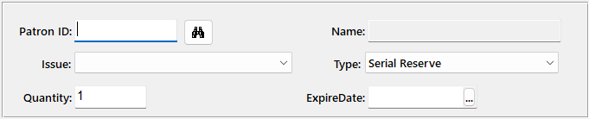

Print Serial Mail Cards
- In the Circulation Module, open the Mailing Cards function.
- In Mailing Cards/Labels:
  - For duplicated serials, set Batch Type: Dup Order and select the appropriate Medium.
  - For physical serials, set Batch Type: Serial.
- Select the appropriate Stock Name and Current Printer.
- Select Print. A new batch will be created and the cards will print to the selected printer.
- For physical serials, Post the batch once the serials are in the mail. For duplicated serials, the cards post automatically as they are checked out at the Scribe.
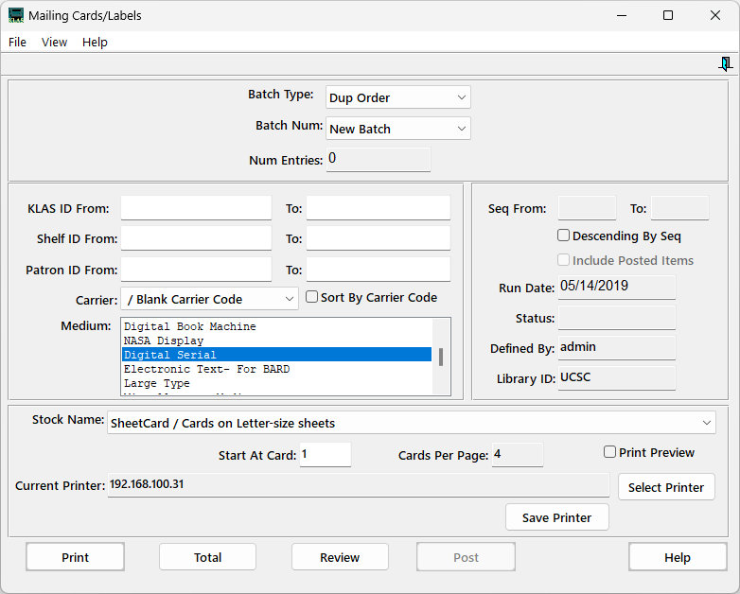

Generate Email Distribution List
A serial can be used to track current, Active subscribers to an emailed Newsletter, but KLAS cannot send the emails. Rather than adding Issues in KLAS, use this record to generate a current email distribution list any time you need it.
When unsubscribing a patron from an emailed serial, the subscription should be Deleted instead of just cancelled; this ensures that your query will include only current subscribers.
- When you Add a new Serial for email distribution (see page 11), we recommend:
  - Medium: Electronic
  - Serial Type: Pub / Publication (will not update the patron’s Last Served date. If you do want the serial to update Last Served, use Cir / Circulating instead.)
  - Consumable
- Use the Issues tab (Alt-7) to Receive a Physical Issue (see page 5). Receive enough copies for all Active subscribers; this count is available on the serial’s Title tab (Alt-1).
- Use the Subscribers tab (Alt-5) to Seed Serial (see page 7).
- In the Patron Module, Query (Ctrl-q) for the active subscribers.
Quick Search:
  - Main Status | Equals | A
  - Library ID | Equals | [your library; only needed if you are serving only one branch in a multi-branch system]
Advanced Search (Alt-2):
  - Blocks | Is Blocked | Equals | no
  - Subscription | KLAS ID | Equals | [the Serial ID, ex: SER-NEW7]
- Begin Search.
- On the Patron Query Results screen, Export to Excel (Alt-Ctrl-x). Make sure the Maximum is set high enough to export all subscribers, and select Visible Fields.
Note: If Email is not included as a column in the Query Results browse table, contact Customer Support to add it.
- Use the Email column from the Excel sheet to copy the email list into your mail program.
- In the Circulation Module, open the Mailing Cards function.
- In Mailing Cards/Labels, set Batch Type: Serial.
  - If you also circulate other Electronic or Physical serials, enter the KLAS ID in the From: and To: fields to limit the card batch to only this serial.
  - Mark Print Preview.
- Print the batch, then Post. This informs KLAS that the issue was sent, adding the Issue and the Sent date to the patrons’ Items tabs.

Troubleshooting Serials
If a Serial does not go out to subscribers when expected, you can follow these steps to help determine where it went off-track. If you need further assistance, please contact Keystone Customer Support.

Duplicated Serials
- Is there an eDoc for the current issue? If not, confirm that the Issue Name matches the File Name (see page 6).
- Do the subscribers have Serial Reserves? If not, try Seed Serial or Service Subscription--note any error messages, and check for any new Reserves (see page 7).
- Are the subscribing patrons set to get Duplication service in this medium? If not, you will need to add a Service Queue.

Physical Serials
- Are there Items available for the current issue? If not, you may need to add inventory using the Receive function (see page 5).
- Are the subscribing patrons set to get Physical service in this medium? If you want Duplication patrons to get a Physical serial, you may need to use a separate Physical Braille medium (see page 15).

General
Issue Sorting: The issues on the Issues tab are automatically sorted from oldest to newest based on the data entered in the Chronology and Enumeration fields (see page 12). If a new Issue is not at the bottom of the list, confirm the selected data for that issue and any sorting below it.
Note that for Seasonal serials, Winter sorts at the end of the year according to the MARC standard; if your Winter issue tends to come out in January or February, you may want to use Quarterly numbering instead of the seasons.

Serials Maintenance

Add a new Serial
- From the Title tab (Alt-1) of any Serial Record, Add a new record. (Ctrl-n)
- A blank Serial Record will open. Fill in the desired information about the new serial.
These standard fields should be used for all serials:
  - Serial KLAS ID – Enter SER- (or your library’s prefix for this serial type) followed by three letters plus a number. Browse the tree view to ensure that you are entering a unique ID. See Serial ID Numbering on page 20 for information on which number to use; most Digital Audio serials should use 4.
  - Medium - Many libraries use a dedicated Digital Serials medium (such as DS) to keep all Serials together in Serials-only orders; others may treat orders as DB / Digital Books to allow them to go out in the same orders as a patron’s books.
  - Title
  - Status
  - Frequency
  - Serial Type – Generally Cir for “local circulation.” See Serial Types on page 20.
- For NLS magazines (MoCs), the Call Number must be set to “DB” followed by the title of the serial, with dashes in place of spaces. For example: DBRolling-Stone
- These additional fields may be used as needed or desired:
- Reading Level and Language – All subscribers are served regardless of reading level or language, but they can be entered for reference and display on the WebOPAC.
- Consumable – Mark this box for physically circulating serials that are not expected to be returned, such as paper newsletters.
- OPAC Suppress – Mark this box if you do not want the new serial to be displayed on your WebOPAC (online catalog). Note: if no serials are displayed on your WebOPAC, this is not necessary.
- Annotation – A brief description of the Serial; can display on the WebOPAC.
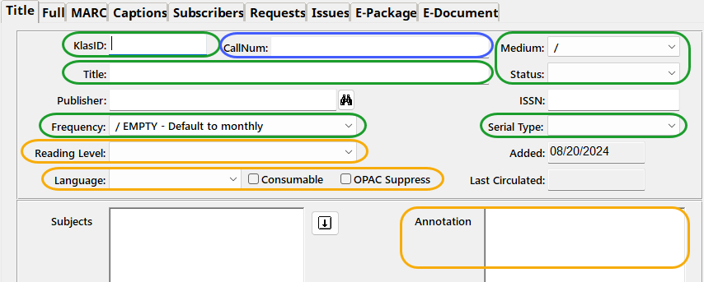
- Once the desired information has been added, Save the new record. (Ctrl-s)

Add a Serial Caption
The Caption helps users generate consistent names for each Issue of local serials. They also define how Issues are sorted, ensuring that KLAS can identify the most recent Issue even if Issues are added out of sequence.
A serial can have multiple Captions; use the CapNum drop-down to select which caption to view. However, only one Basic caption can be Active at a time.

Captions for NLS serials (MoCs)
Because KLAS needs a specific caption to create Issues for new NLS serials, please leave these to Keystone Support.

Captions for local serials
- Select the Serial and go to the Captions tab (Ctrl-4).
- If the serial already has a caption, Update (Ctrl-o) the old caption, change it to Active: no, and Save (Ctrl-s) before adding the new caption.
- Add a new caption (Ctrl-n). Set the Active field to yes by typing “Y”.
- Determine what you want your Issue Names to be, keeping in mind the need to match your filenames or UIDs with the Issue Names.
Available tokens for use in Issue Names:
- Enumeration - If your serial uses a numbering system that is not specifically connected with when that issue came out, use Enumeration. Ex: using “Issue #” clearly labels Issues regardless of how many or few happen to come out each year.
- Chronology – To name your serial based on when it was released, use Chronology. This will always sort after Enumeration, meaning that Issues in a certain “Volume” (Enum) will sort together regardless of the selected Year (Chron).
You can use as many or as few tokens as needed to keep your Issue Names unique; an annual Serial may have only “Volume” or Year, while a weekly Serial may have Year, Month, and Day.
- Define the tokens in your desired Issue Name using the fields in the middle of the screen. The order of the tokens will control how your Issues are sorted, so they must be entered from least to most specific regardless of where they will occur in the name.
Ex: Chron 1 - Year, Chron 2 - Month, Chron 3 - Day for a weekly serial.
We recommend keeping your tokens consistent across local serials as much as possible (for example, always setting Month to the same Value Group, not sometimes Numeric and sometimes Short Month).

- Enumeration is always checked first to set the order for Issues, from Enum 1 to 6.
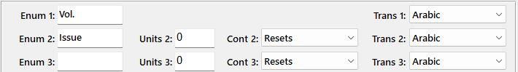
- Chronology is considered after Enumeration from Chron 1 to Chron 4.
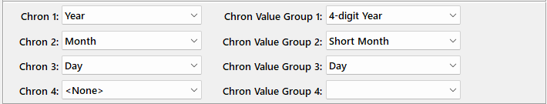
If using Season as one of your Chronology tokens, bear in mind that Winter will sort as the last issue of the year following the MARC standard. If your Winter issue tends to come out in January or February, consider using Quarter instead of Season.
- Enter the desired Caption Pattern. We recommend making your pattern:
- Short (For Example: using the three letters after the serial prefix in the KLAS ID, instead of the full serial title)
- Unique both from issue to issue and from serial to serial
(“nwl-@Chron1@-@Chron2@” instead of just “@Chron1@-@Chron2@”)
- Not contain any spaces or punctuation besides dashes and underscores
(“Egad-@Enum1@-@Enum2@” not “Egad! @Enum1@-@Enum2@”)
- Consistent (always setting Chron2 of quarterly serials to Quarter, not sometimes Quarter and sometimes Season)
Example: the pictured Chron token settings and Pattern would result in Issue names of “QJ4_2025-02” and “QJ4_2025-03”
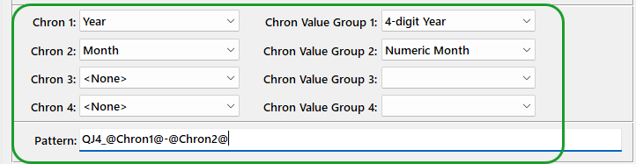
For more information on matching filenames to Issue Names for local serials, Upload a file for Duplication on page 6.
- Save the Caption. (Ctrl-s)

Add or Update Holding and Retention
If a serial is not set to Retained, KLAS will serve the serial starting with the oldest issue with an eDoc, no matter how many are added afterwards—we recommend giving all serials a retention, so that KLAS will start new subscribers with more recent issues.

Add a New Holding
- If a serial does not yet have a Holding, right-click on its entry in the tree view to select Add Holding.
Alternatively, use the Receive function to add the holding:
- Use the Serials module Functions menu to select Receive Issue.
- On the Serials Receive screen, enter the KLAS ID of the serial, or use the Lookup button to find it. The Title for the current KLAS ID will be displayed.
- Use the Add Holding button; continue as below.
- Set the appropriate Library Branch and Shelf ID.
- Set the General Retention to Retained (if back-issues will be kept for use on request) or Not Retained (if back-issues will not be kept).
- Set the Specific Retention to the number of issues that should be reserved for new or returning subscribers. For more information about the Retention settings, see Understanding Retention on page 20.
- Save all changes. (Ctrl-s)
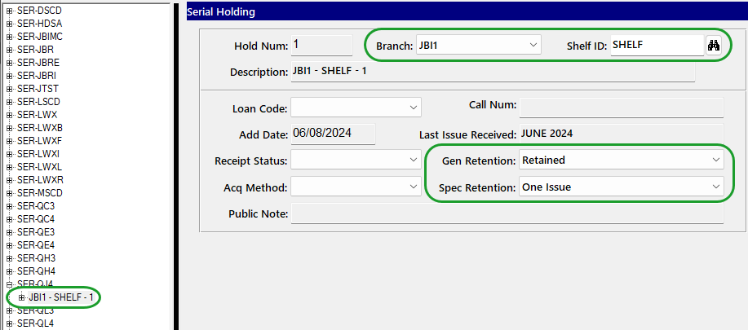

Change a Serial’s Medium
Serials in the DB / Digital Books media format can be distributed to DB Duplication patrons along with their regular book service. However, if they are both using the DB Medium, KLAS will combine both Serial and Monograph DBs into a Single Service Queue. Duplication Orders that are generated may contain both Serials issues and Monograph titles, and cartridges checked out with either would count toward a single cutoff.
If you prefer to keep Serials and Monographs separate, on separate cartridges and with separate profile settings, you can do so by converting the serials to an alternate Medium. However, once a Serial has been duplicated in one Medium, it cannot be changed to a different one.
Contact Customer Support for assistance if you need to change a Serial to a different Medium.

Withdraw an Issue
Once an issue is no longer Retained (see Understanding Retention on page 20), KLAS will no longer automatically Reserve it for patrons, without the need to Withdraw it.
However, if an issue of a time-sensitive serial (such as a local newsletter or voting guide) becomes outdated before the next issue is available and should no longer be circulated, you can withdraw the issue when you are ready to stop sending it.
If in doubt, don’t delete.

Withdrawing Duplication on Demand Issues
Only local serial issues should be withdrawn. If there is a problem with an issue of an NLS serial, please contact NLS and Keystone Customer Support.
- Check the Requests tab (Alt-6) and Delete all requests (Ctrl-d).
For any Reserves currently on a Service Queue or in a Duplication Order:
  - Double-click or Select and Enter each Reserve with an SQ status and Delete (Ctrl-d) them from the Service Queue.
  - Double-click or Select and Enter each Reserve in DO status and cancel the orders using the Functions - Duplication Orders menu. If you select the option to return the titles to the Service Queue, then Delete (Ctrl-d) the serial issue from the queue.
- If the next Issue of the Serial is not yet available, the Serial Title record should be set to Withdrawn until a new Issue is available.
- Once the new Issue is added, set the Serial’s Title status back to Active. Confirm that the Serial’s Retention does not include the Withdrawn issue (see page 14).
Do not delete the issue record in KLAS—this should remain on the serial for historical and statistical purposes. EDocs cannot be deleted once they have circulated.

Withdrawing Physical Issues
- Expand the tree view to Issue View, and expand the Issue you want to Withdraw.
- Select each copy listed under that Issue.
  - If the Cir Status is OUT, use the Patron module to Find (Ctrl-f) the patron. Select the Item on the Patron’s Items tab (Alt-6) and mark it Lost (Functions Menu - Items tab).
  - If the Cir Status is ASG, use the Patron module to Find (Ctrl-f) the patron. Select the Item on the Patron’s Items tab (Alt-6) and UnAssign (Alt-Ctrl-g).
- Once you are sure no copies for that Issue are Out or Assigned, the Issue can be deleted if you are certain that it is no longer wanted on the record.

Withdraw a Serial
When the serial as a whole should no longer be circulated, you can choose how completely you want to Withdraw it depending on whether you want to provide back-issues on request, and how likely the serial is to be resumed.

Update Title Record
- On the Record’s Title tab (Alt-1), Modify the record (Ctrl-o).
- Change the Title Status:
  - To Withdrawn if you no longer want to provide back-issues. This will block all duplication of this title.
  - To Retrospective, Download Only, or similar to indicate that the title is no longer Active, while still allowing duplication on request.
- To provide the information at-a-glance on the Patron module Subscriptions tab, some libraries also:
  - Add “Discontinued” or similar to the Title. (Ex: Rolling Stone - Discontinued)
  - Add an X or Z to the KLAS ID.
Adding the character to the beginning of the KLAS ID or just after the prefix (xSDS-OPR4 or SDS-zOPR4) will group discontinued serials together alphabetically; this can make it easier to browse the Active serials, but it can also make it harder to find a specific serial if you do not know the current status.
Adding the character to the end of the KLAS ID (SDS-OPRx) will leave the serial in its original place alphabetically, while still clearly marking the ID as inactive.
You should determine what changes your library wants to make to the Title record and apply them consistently.
- Save the record when finished (Ctrl-s).
- To copy the subscribers to a replacement serial, contact customer support to batch Cancel / Transfer all subscribers (see page 19).
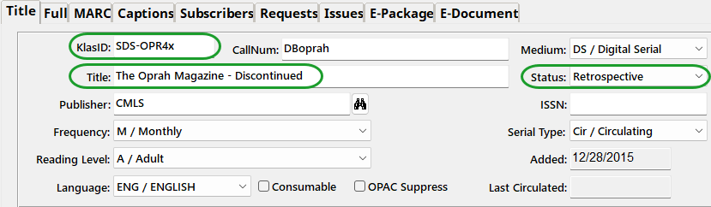

Delete the Title Record (not recommended)
If the Serial was a local serial or a long-discontinued MoC serial, you no longer want to distribute back issues via Duplication or WebOPAC, and you are sure you will not resume circulation of the serial, you may choose to delete the record.
If in doubt, don’t delete.
In addition to the above Title Record Updates:
- Withdraw any physical issues; see Withdraw an Issue on page 16.
- Check the Requests tab (Alt-6) and Delete all requests (Ctrl-d).
For any Reserves currently on a Service Queue or in a Duplication Order:
  - Double-click or Select and Enter each Reserve with an SQ status and Delete (Ctrl-d) them from the Service Queue.
  - Double-click or Select and Enter each Reserve in DO status and cancel the orders using the Functions - Duplication Orders menu. If you select the option to return the titles to the Service Queue, then Delete (Ctrl-d) the serial issue from the queue.
- Delete (Ctrl-d) all subscriptions; to give them a replacement subscription first, contact customer support (see page 18).
- Once there are no remaining Requests or active subscriptions, you can Delete the serial (Ctrl-d) from the Title tab (Alt-1).

Resume a Serial
If a withdrawn serial becomes active again (but was not Deleted):
- On the Record’s Title tab (Alt-1), Modify the record (Ctrl-o).
- Revert any changes made when withdrawing the title, such as:
- Un-check OPAC Suppress box to resume displaying the serial on the OPAC.
- Remove any reference in the Title to being withdrawn/discontinued.
- Remove any x or z added to the KLAS ID indicating that it was withdrawn/discontinued.
- Set the Title Status to Active.
- Save the changes (Ctrl-s).
- Clean up subscribers list and contact customer support to Cancel / Transfer all subscribers from another serial (see page 19) if needed.

Cancel Subscribers

Cancel single subscriber
Any single subscriber can be cancelled from either the Patron module Subscriptions tab (Alt-8) or the Serials module Subscribers tab (Alt-5).
Preferred Method:
- In either module, select the subscriber / subscription to be cancelled and Update the record (Ctrl-o).
- Enter the current date in the End Date (Serials module) / Cancelled date field (Patron module).
- Save the changes (Ctrl-s).
Alternate Method (preferred for emailed serials):
- In either module, select the subscriber / subscription to be cancelled and Delete the record (Ctrl-d).
Cancelling the serial record by adding an End Date retains the history of when the patron started and stopped receiving the serial. However, deleting the subscription is also acceptable.

Cancel / Transfer all subscribers
A batch program can be used to cancel all subscriptions for a given serial or list of serials
When running the program to cancel a serial, a different serial can be designated to replace it. If using this option, all subscribers of the cancelled serial will receive a subscription to the replacement serial.
There is no batch option to resume all subscriptions, so batch cancel with care!
Contact customer support to request a Batch Cancel / Transfer, with the Serial ID(s) to cancel, and any replacement IDs.

Resume a Subscription
To resume a cancelled subscription, Update the record (Ctrl-o), and delete the End Date / Cancelled date. You can either leave the original Add Date or update it to the current date. Save the changes (Ctrl-s).
If the subscription was deleted instead of cancelled, it can be re-added as a new subscription (Ctrl-n).

Standard Functions & Terms

Serial Terminology

Serial Types
- Dir/Direct - Direct Serials are sent directly to the patrons from NLS. If the patron has any Direct serials, their Dir Status will automatically be set to Active. Direct serials are not stopped by making the patron Inactive in the medium or by a Block on the account.
- Cir/Circulating - Circulating Serials are circulated by the local library, such as locally-produced serials or NLS “MoC” Serials. To receive Circulating serials, a patron must have their Cir Status set to Active, and not have any Blocks on their account.
- Pub/Publication - Publications are serials sent out by the library that should not count as having served the patron, such as Newsletters.

Serial ID Numbering
The numbers at the end of each Serial ID are used by NLS as an indicator of a serial’s format. The code is as follows:
- Braille
- Large Print
- Cassette - now reissued as Digital Audio
- Digital Audio
- Digital Braille
7. Electronic / Download

Understanding Retention
The Specific Retention (“Spec” Retentions) defines the number of issues that will be Reserved for new subscribers, or that are eligible to be Reserved when serving a subscriber that has previously been on hold or at their Cutoff.
When Reserving issues for a patron, KLAS will only add issues that are retained, come after the patron’s previously received issue sequentially, and that the patron has not already had.
For example, if a patron last had the February issue of a Monthly serial, and next needs service in April:
- If the serial has a retention of One Issue, only the April issue will be Reserved, since it is the only unread Retained Issue.
- If the serial has a retention of Two Issues, both the March and April issues will be Reserved, since they are both unread Retained Issues.
- If the serial has a retention of Three or more issues, only the March and April issues will be Reserved, since any earlier Issues were either already received (February), or came before the last received issue sequentially (January).

The Toolbar
The toolbar at the bottom of most KLAS screens provides easy access to the most common functions for that screen, in particular the basic records functions.
Screen reader users can access these functions from the menus instead, or many of these functions have keyboard shortcuts.
The basic record functions are: Add, Update, Copy, Delete, Save, Reset, and Cancel.
- Add (Ctrl-n) to create a new, blank record. On the Main tab of a module, that will be an entirely new record, such as a new patron or a new catalog title. In other locations, it will be a new entry in the table of that screen, such as a new Medium Profile on the Profile tab or a new Preference on the Preferences tab.
- Update (Ctrl-o) to open a record for updates. No changes can be made or saved to an existing record unless you use Update first to enable these changes. New or Copied records are created already open for updates, so you can get right to work.
- Copy (Alt-Ctrl-s) a record to create a new, identical version, which you can then update prior to saving. Not all screens allow you to copy records.
- Delete (Ctrl-d) a record to remove it from KLAS. On the Main tab of a module, delete will remove the entire record, such as the whole patron. Otherwise, it will only delete the selected table entry. Always use caution before deleting records from KLAS! When in doubt, ask if a particular type of record is ok to delete.
- Save (Ctrl-s) will be disabled and appear light grey until a record is open for Updates and changes have been made. Once a record has been opened, you should always either Save or Cancel before changing screens.
- Reset (Alt-Ctrl-z) will be disabled and appear light grey until a record is open for Updates and changes have been made. Reset a record to remove any changes since the last Save, while still leaving the record open for Updates.
- Cancel (Ctrl-z) will be disabled and appear light grey until a record is open for Updates and changes have been made. Cancel will discard any changes since the last Save and close the record.

Browse Tables
Many of the screens in KLAS have at least one table.
- Some screens provide filters or search fields, allowing you to reduce the number of records in the table and show you only the most relevant information.
- Some screens provide data fields, allowing you to view more information about the selected record and/or make changes to it.
- For most browse tables, you can select any column header to sort the rows by that column. Select the header again to reverse the sort order.

Rearrange Columns
You may find tables in KLAS that do not put the information you need the most in the order that is most convenient for you. You can set your own column order for these tables, which will be applied only to your own log-in.
- Right-click anywhere in the browse table and select Move Columns.
- Left-click and hold down a column header and drag it to the desired location.
- Drag the bar between columns to adjust the width of the column to the left of the bar.
- Once columns are in the desired order, right-click in the browse table and select Save Column Positions and Sizes.
Note: This one-time set up requires use of a mouse. Column position will be adjusted for Screen Reader users as part of AT Training; for later adjustments, AT users may need assistance.

Export
A common toolbar icon is Export to Excel, which will open the contents of that screen’s browse table in Microsoft Excel. (Alt-Ctrl-x)
You can choose to export only the Visible Fields included on the screen, or export All Fields to include all of the data for that table.
You must have Excel installed on your workstation for this to function correctly.
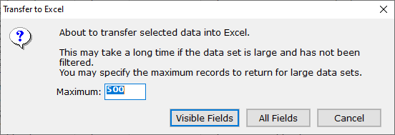
Some example tables where Export to Excel can be useful:
- To send a patron a list of their upcoming Duplication titles, Export their Service Queue tab. Leave the default Maximum and select Visible Fields. Delete any unnecessary columns in Excel, then print or email the spreadsheet to the patron.
- To create a list of patrons in a specific city, use Find (Ctrl-f) and fill in the City field to filter the browse table. Use Export on the Find screen, set a high enough Maximum to include all patrons in that city, and export All Fields to include additional Contact information, such as email and mailing address.
- To create a list of current subscribers to a certain serial, Export the serial Subscribers tab with the filter set to Active. If desired, the list can then be additionally filtered in Excel based on Patron Status, Library ID, and so on.

