

Transfer Patron &
Equipment Records
  - For KLAS Version 7

Keystone Systems, Inc.
8016 Glenwood Ave., Suite 200
Raleigh, NC 27612
800-222-9711
ks7@klas.com
Contents
Initiating Transfers 2
Transfer Out 2
Re-Transferring 3
Transferring Outside of the USA 3
Transfer In 4
Branch Transfer 5
Accepting or Rejecting Transfers 6
Accept a Transfer In 6
Transfer In Equipment 7
Reject a Transfer In 8
Accept or Reject a Transfer Out 9
About Patron Transfers 10
What Information is Transferred? 10
Preference Matching 11
Records Maintenance 11
What is PIMMS? 12
Transfer Notifications 12
Troubleshooting & FAQ 13
Patron is Deleted or Merged errors 13
Missing a Transfer-In record? 14
Patron is not Active in Medium XY 14
Check Transfer Status 14
Appendix – Error Listing 15
Initiating Transfer Errors 15
Activating / Accepting Transfer Errors 16

Initiating Transfers
When a patron notifies you that they are going to move, or has already moved, initiate the Transfer based on where they are moving:
- Transfer Out – use if the patron is moving from your library to a new one.
- Transfer In – use if the patron is moving from somewhere else to your library.
- Branch Transfer – use if the patron is changing branches within the same system.

Transfer Out
If one of your patrons needs to be transferred out to a different library system, use the Patron Transfer: Initiate Outgoing function.
- If there is any NLS equipment which the patron is not taking with them, make sure that it is checked in or marked lost prior to transferring the patron. In particular, make sure any C1 machines or other obsolete equipment are no longer on the patron’s record.
- In the Patron module, use the Functions menu to select Patron Transfer. (Alt-Ctrl-t)
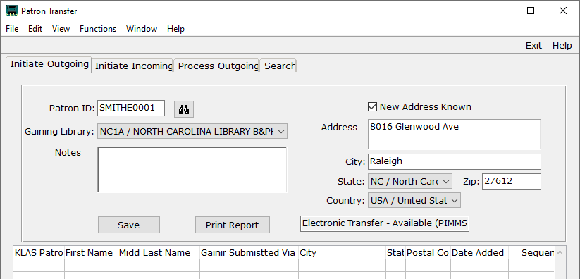
- On the Patron Transfer screen, use the Find button to select the record to transfer.
- Select the Gaining Library that should receive the patron record.
- If you know the patron’s new address, select the New Address Known checkbox and enter the address in the available fields.
- Once all known information is entered, select Save.
Your copy of the record will immediately be given a Main Status of Transferred Out, and the receiving library will receive their copy overnight. Any NLS equipment that is checked out to the patron will also be transferred.
Per NLS policy, the Patron’s application should also be sent to the gaining library.

Re-Transferring
If your initial transfer was rejected (usually due to sending it to the wrong library), you can re-do the transfer.
- Once the initial receiving library rejects the transfer, PIMMS ownership of the patron will be passed back to you overnight, as part of the nightly sync.
If you do not want to wait overnight to proceed, look up the transfer number (see Check Transfer Status on page 14) and contact us to sync the transfer status immediately.
- On the Patron Main tab (Alt-1), use the Update Record button. (Ctrl-o)
- Change the main Status to Active and Save the record. (Ctrl-s)
- As part of the original transfer, all of the patrons Subscriptions (Alt-8) were cancelled. The transfer logic automatically resumes Subscriptions that were cancelled the day of the transfer, but since you are re-activating the record instead of accepting a transfer, you will need to resume these Subscriptions manually.
Update (Ctrl-o) each Serial that should be continued for the patron, highlight the Cancelled date, and use your keyboard Delete key to remove it, then Save the record. (Ctrl-s)
- Repeat the regular Transfer Out process as on page 2.

Transferring Outside of the USA
Patrons who are moving outside of the country can still be served by NLS. Transfer their record as usual, but select LC*3 as the gaining library.
When entering the patron’s new address, make sure to include the specific country. If you are unable to enter the new mailing address in full, contact Customer Support for assistance.

Transfer In
If a patron new to your service area informs you that they previously received service elsewhere, use the Patron Transfer: Initiate Incoming function.
- In the Patron module, use the Functions menu to select Patron Transfer. (Alt-Ctrl-t)
- On the Patron Transfer screen, select the Initiate Incoming tab. (Alt-2)
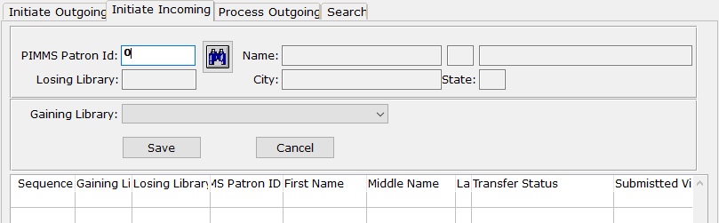
- Use the Find button to look up the PIMMS patron record to be requested. On the PIMMS Lookup Patron screen:
  - Enter the patrons First and Last name, then use the Search Pimms button.
(Note: The Name fields are not individually labeled; the first field is for the given name, the second field is for the surname.)
  - Select any record to view more information.
  - Once you have located the patron’s record, double-click the row or use the Select this Patron button. You will be returned to the Patron Transfer screen with the patron’s PIMMS ID and basic information loaded.
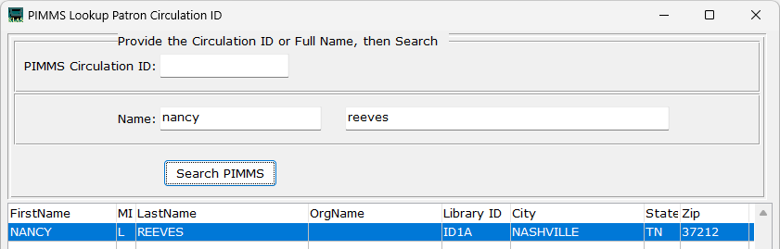
- Select your library (or the appropriate branch within your system) as the Gaining Library.
- When you have confirmed that the correct information is selected, use the Save button.
The transfer request will be submitted to the patron’s previous library overnight. Once they approve the transfer, the record will be added to your system during that night’s sync. You should review this information as you would any time you Accept a Transfer In (see page 6).
It is the sending library’s responsibility to also send the Patron’s application when they approve the request.

Branch Transfer
In multi-branch systems, a patron can be easily transferred to a different branch within the same system by updating the Library selected on the patron Main tab. (Alt-1)
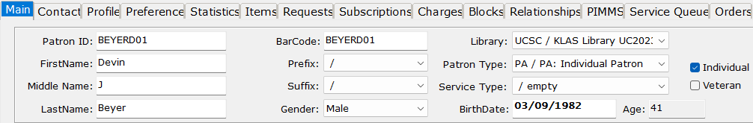
Depending on library settings, the Patron’s Main Status may be set to T/Transferred Out, in which case the receiving branch will be notified and need to Activate the patron upon review to Accept a Transfer In just like with a standard PIMMS transfer (see page 6).
If this is not enabled, the record will be left at A/Active status and the gaining branch will not be notified. To change whether or not the patron’s status changes in your system, contact Customer Support.
Branch transfers are communicated to PIMMS, but the patron’s record will not be changed (other than a Main Status change as described above), and no transfer notes will be generated.

Accepting or Rejecting Transfers
You should always Accept or Reject transfers promptly to help keep PIMMS up-to-date. A contact person at your library will be notified of any pending transfers by email (see Transfer Notifications on page 12)

Accept a Transfer In
Records transferred to your system will be added with a Main Status of Transfer In.
We recommend that you review the record thoroughly, including:
The patron’s Profile (Alt-3)
- Service Types can vary between libraries, as well as policies regarding the max number of allowed cartridges (NSCutoff).
- Duplication info such as Titles per Cartridge does not transfer, and should be added.
The patron’s Preferences (Alt-4)
- KLAS does its best to match information from the losing library’s database to the options available in your database, but you should watch the transfer notes for any mis-translations and anything it cannot match. (See Preference Matching on page 11.)
The patron’s Items (Alt-6)
- Any machines listed in the transfer notes that do not transfer in automatically will need to be transferred manually (see page 7).
Once you have reviewed the Patron’s record:
- On the Patron Main tab (Alt-1), use the Update Record button. (Ctrl-o)
- Change the main Status to Active.
- Save the record. (Ctrl-s) This Accepts the Transfer, updates PIMMS accordingly, and triggers the transfer-in of the equipment.
- Switch to the Profile tab (Alt-3). Update (Ctrl-o) the patron’s Media records to Active status as well, or to whichever status is the most appropriate. Depending on library settings, this may have been done automatically.
- Save each Medium record when finished. (Ctrl-s)
- Switch to the Items tab (Alt-6) and check that any NLS equipment (such as a DA1 - Digital Talking Book Machine) in the transfer notes is listed as OUT. Transfer any missing equipment if needed.
Note that the patron’s exact Birth Date does not transfer, only the Birth Year. If you wish to have the patron’s Birth Date on file, you will need to update it based on the original application.

Transfer In Equipment
Most of the time, NLS equipment will transfer with the Patron record. However, if the equipment listed in the transfer notes is not listed on the Patron Items tab, it should be transferred manually.
- In the Equipment module, use the Functions menu to select Equipment Transfer.
- Set the radio button to Transfer In.
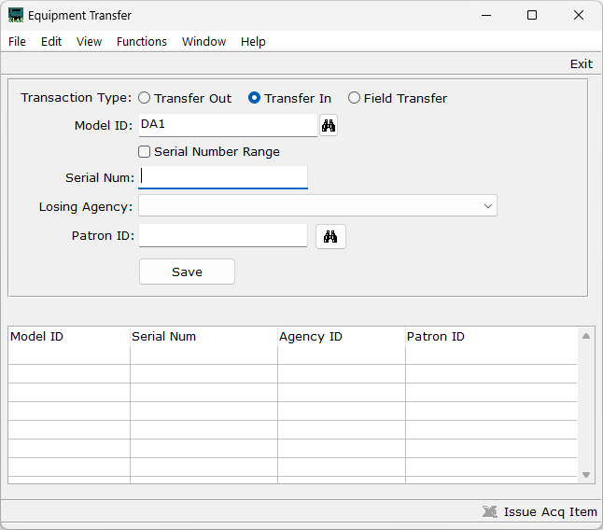
- Enter the Model (DS1 / DA1), Serial Number (from the transfer notes), and the transferred patron’s new Patron ID.
- Use the Save button.
The system will check with PIMMS, then add the machine to your inventory and check it out to that patron.
If there is an error triggered in this process, or if the machine is still not on the patron’s account the following day, please email Customer Support at ks7@klas.com with the Patron ID and the exact error message and/or the Model and Serial Number.

Reject a Transfer In
If the wrong library was selected to receive a patron, or if you need to Reject a transfer for any other reason, you should do so promptly to ensure that the transfer can be re-sent to the correct location, or that the patron can resume service at their home library.
- On the Patron Main tab (Alt-1), use the Update Record button. (Ctrl-o)
- Change the main Status to Suspended.
- Save the record. (Ctrl-s) This Rejects the Transfer and updates PIMMS accordingly during the nightly sync.
- Add a Comment (F3, Ctrl-n) to note that the transfer was rejected.
- Inform the sending library. There is nothing automated to notify the other library; you need to let them know the transfer was rejected so they can re-activate the record and handle it from there.
- If desired, Delete the record (Ctrl-d) from the Patron Main tab the following day, once the nightly sync has been completed.

Accept or Reject a Transfer Out
When another library initiates a transfer request for one of your patrons, you can either accept or reject the transfer.
- In the Patron module, use the Functions menu to select Patron Transfer. (Alt-Ctrl-t)
- Switch to the Process Outgoing tab (Alt-3). All pending transfer requests will be listed.
- Select the transfer request to process, and use either the Approve Transfer button or the Reject Transfer button as appropriate.
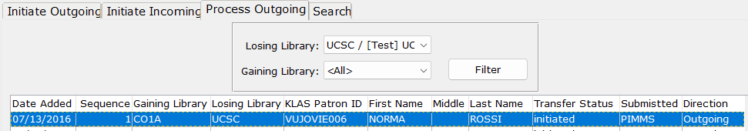
If you Approve the transfer, your copy of the record will immediately be given a Main Status of Transferred Out, and the receiving library will receive their copy overnight. Any NLS equipment checked out to the patron will also be transferred.
With Outgoing transfers initiated by the gaining library, there is no prompt to enter the patron’s new address. If you have been notified of the patron’s new address, you should enter it as usual on their Contacts tab (Alt-2) prior to accepting the transfer. Otherwise, the gaining library can update the address after receiving the record.
Per NLS policy, the Patron’s application should also be sent to the gaining library.
If you Reject the transfer, the pending transfer will be closed in PIMMS, allowing the sending library to re-Activate the patron and preventing future errors transferring the record. You should inform the sending library once you have rejected the transfer.

About Patron Transfers
When a patron moves, the record of their service, preferences, reading history, and currently checked-out equipment can go with them to their new serving library.
Transfers can be initiated by either the losing or gaining library at any time. These transfers are processed overnight, at which time the new patron record is added to the gaining library and a notification is emailed to the contact person on file.
Per NLS policy, the patron’s application must be sent to the gaining library. Please have a local workflow in place to ensure the application is sent.

What Information is Transferred?
All transfers are sent via PIMMS (see page 12), but KLAS transfers in and out more information than WebREADS, the software used by most non-KLAS network libraries. If a transfer is coming in from, or going out to, a WebREADS library, less information will be included.
Information transferred to and from all libraries:
- Patron’s full name
- Most information on the Patron Main tab, including the full Birth Date
(previously, only the year was sent)
- Current / New mailing address
- Medium Profile information (not including duplication-specific settings)
- Current phone number and email address (if present)
- Currently out NLS equipment (such as the digital talking book machines)
- HasNow (currently checked out titles, will be loaded as HasHad)
- HasHad (previously checked out titles)
- Subscriptions
- Reserves and Requests
Additional information transferred to and from KLAS libraries:
- Patron Preferences (see Preference Matching on page 11)
Information that does not transfer:
- Comments
- SSN field on Patron Main
- Service Queue
- Duplication Orders

Preference Matching
KLAS attempts to transfer a patron’s preferences when transferring the record between KLAS libraries. However, many libraries use somewhat different wording and may not have exact matches for all of a patron’s preferences.
To match subjects, KLAS looks only at the Full Description (not the Code), and it has to be an exact match.
In some cases, you’ll need to apply your own judgement. For example, a patron at Library A may have an exclusion for “Contains Violence.” However, Library B may have the headings “Some Violence” and “Explicit Violence” instead.
If the above patron transfers to Library B, it would likely be the best option to give the patron an exclusion for both “Some Violence” and “Explicit Violence.” In other cases, a conversation with the patron may be needed to determine the best preferences.
Any Preferences that KLAS cannot match to records in the gaining library will be noted in one of the Transfer Comments. Be sure to check the Transfer Comments to make sure KLAS found appropriate matches for the patron’s preferences, and to check for any additional preferences you should add!

Records Maintenance
Unless your organization’s Records Maintenance policy requires otherwise, records that have been at T/Transferred Out status for at least a year can be Deleted (either using the Purge stage of the Batch Patron Status Review tool, or from the Patron Main tab).
T/Transferred Out records cannot be set to a different status manually, because a manual status change cannot change ownership of the patron in PIMMS (see page 12). The only exception to this is if you are still the owning library. There are two cases in which a patron record can have Transferred Out status, while you are still the owning library:
- If the receiving library Rejects a transfer (See Reject a Transfer In on page 8), PIMMS ownership of the patron returns to your library overnight. See Re-Transferring on page 3 for more information.
- With a Branch Transfer (see page 5), the status may be set to T/Transferred Out depending on the library’s configuration.
In this case, the receiving branch can change T/Transferred Out to A/Active upon review since they are the new owning library in PIMMS.
If the patron was previously transferred (and the transfer was accepted), but has now returned to your library, initiate a Transfer In (see page 4) instead of changing the status directly.

What is PIMMS?
PIMMS is the Patron Information and Machine Management System, a nation-wide database of patrons and equipment administered by NLS (the National Library Service for the Blind and Print Disabled at the Library of Congress) for statistical and tracking purposes.
For the most part, information about your patrons is maintained in KLAS and synced to PIMMS automatically, with your version of the information overwriting any previous information in PIMMS.
However, there are some cases where PIMMS has the final word. For example, if PIMMS considers Library A to have ownership of a particular patron’s account, then only Library A can sync changes to that account.
Additionally, if a patron’s PIMMS status is Merged, then no further changes can be synced to it and the Active account must be located and used instead.
PIMMS also facilitates transfers between libraries, both changing the PIMMS record of ownership of the account, and passing additional information from one network library to another, even if those libraries use different Library Automation Software.

Transfer Notifications
When a record is transferred into your system, or a transfer for one of your patrons has been requested by another library, the system will automatically generate a notification email.
This email is sent to the contact person on record for the library. To change the address this email is sent to, contact Customer Support.

Troubleshooting & FAQ

Patron is Deleted or Merged errors
If you attempt to Transfer Out a patron but get an error message indicating that they are Deleted or Merged, check the PIMMS tab (Ctrl-2).
This error is referring to the PIMMS Status, not the status of the KLAS record.
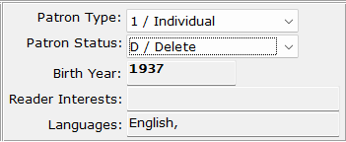
If the record is Deleted: check that their KLAS record is Active, then use the Functions menu to select Profile – PIMMS Sync Now. This will sync the current status to PIMMS. Once the PIMMS Status is Active, other changes, including transferring the patron, can be made.
If the record is Merged: check to see if you have another record for that patron with an Active PIMMS status, or a Suspended / Deleted PIMMS status (which can be re-activated by making the KLAS record Active).
If needed, you can copy the merged record’s reading history and requests to the other record using the Merge Patrons function in the Tools menu.
  - When you Merge patron records, always make sure you have the records in the correct order. The “to Merge” record’s PIMMS account will be given a “Merged” status, and cannot be re-activated.
  - Set the “Merging Patron New Status” to W / Withdrawn. Review the records to make sure the new record with an Active PIMMS status has all the relevant information from the old record. Then, you can Delete (Ctrl-d) the old record from the Main tab.
Once you have confirmed that all the information you want to transfer has been copied to the new record, re-try the Transfer, making sure to select the patron’s new record.
If you need assistance creating or merging the record, please contact Customer Support.

Missing a Transfer-In record?
If you have been notified that a certain patron was Transferred In but cannot find their record, check for a Deleted record: in the Patron module, use the Tools menu to select Restore Deleted Patron. Use the Restore Deleted Patron screen to look up the record and restore it.
(Note: This should no longer be necessary in most cases.)

Patron is not Active in Medium XY
When you set a Transferred-In patron to Active, KLAS does its best to re-activate all parts of the record, including Medium Profiles, Subscriptions, and HasNow Equipment. Some of these parts are interdependent, and sometimes the process gets stuck in a situation where it can’t re-activate everything it needs.
If this occurs, please email Customer Support at ks7@klas.com with the Patron ID and the exact error message, and we will force the re-activation of the conflicting data.
Do not delete the Medium record, even if it is not one you use at your library.

Check Transfer Status
If you have questions about whether or not a transfer has gone through, or need the transfer number, you can look up any transfer using the Patron Transfer: Search function.
- In the Patron module, use the Functions menu to select Patron Transfer. (Alt-Ctrl-t)
- Switch to the Search tab (Alt-4). All transfers involving your library will be listed, with the transfer number (unique identifier) and current status.
- Use any combination of the search fields to narrow the results, then use the Search button.
- If the transfer you are looking for is not listed, use the Clear button to empty all search fields, and try a less restrictive search (or just try again, in case of typos).
- If you need a listed transfer updated immediately, rather than waiting for the nightly sync, contact Customer Support with the transfer number.
If you have further questions about the transfer or need help troubleshooting, contact Customer Support at ks7@klas.com.

Appendix – Error Listing

Initiating Transfer Errors
Error Message | Solution
MaintainPatronTransfer - Initiate Failed Can not transfer a patron with a status of deleted | The patron’s PIMMS record is Deleted. Reactivate the patron to unlock the record. See Patron is Deleted or Merged errors on page 13
MaintainPatronTransfer - Initiate Failed Can not transfer a patron with a status of merged | The patron’s PIMMS record is Merged. Check for another record, or create a new patron record and merge the old info into it. See Patron is Deleted or Merged errors on page 13
ttPIMMSPatronAddress already exists with 1. (132) | On the patron Contact tab, the Contact Preferences table on the bottom right should only have one Shipping address. Select the extra Shipping address and use the Delete Contact Preference button or function.
?^AF^1^writepretransvalidate ps.patronxferdescupdater:createprocess ks. genericupdater FirstName […etc] | Check Transfer Status (see page Error! Bookmark not defined.). The patron most likely already belongs to another library in PIMMS. Contact the owning library to have them transfer the patron.
MaintainPatronTransfer - Initiate Failed Cannot initiate patron transfer; patron belongs to an existing pending transfer. […etc] | The patron record is already in a pending transfer. The brackets following this message include the involved libraries and the date the pending transfer was initiated. Contact the other library to have them complete the transfer.
MaintainPatronBean - Add Failed Circulation ID must be unique per Library | A duplicate PIMMS ID exists for this patron, or there is another patron with the same PIMMS ID. Contact Keystone Customer Support with the Patron ID.
WARNING: Transfer was initiated successfully, but the KLAS Transfer record setup failed. […etc] | The PIMMS portion of the transfer was initiated successfully, and the gaining library will receive the patron. However, please contact Customer Support with the Patron ID so we can correct the KLAS tracking of the transfer. Please do not attempt to re-transfer the patron.

Activating / Accepting Transfer Errors
Error Message | Solution
Patron [Patron ID] is not active in medium “DB”. | Contact customer support with the Patron ID. See Patron is not Active in Medium XY on page 14 for more information.
The serial number ###### does not exist in PIMMS. This item cannot be added to KLAS until it exists in PIMMS. | A machine checked out to the Patron needs to be added to PIMMS. Contact Customer Support with the Patron ID, machine type (see the transfer notes), and serial number.
Item "" for title "DS1" does not have a barcode, but a barcode is required for the "CheckOut" operation. | Contact customer support with the Patron ID and error message.

