Machine Count by Status Report

Process overview
NLS has requested counts of how many machines each library has for each PIMMS status. To facilitate this, we have created the Machine Count by Status Report.
This report will be run through the Batch Manager at the end of machine processing on the last day of the month; you should also run it right away as a test to check for any data issues. The report includes the PIMMS Status ID, KLAS Status, and PIMMS Status Description.
The report only considers a machine’s Holding location—each library or branch with a machine holding should run the report.
Check your Holdings by opening the DS1 record in the equipment module. On the Holding tab, look to see what branches have a listing. If there are any errors (for example, if a closed branch still has copies in a Holding), please contact us.
If you have any difficulty running the report or need help addressing any data issues it reveals, please contact Customer Support as soon as possible.
Thank you for your assistance with providing this information to NLS as requested!
- Open the Batch Manager from the View – Administration Menu.
- Create a new job and Schedule it as appropriate.
  - Program: eq/rpt/machinecountbystatusp.p
  - Param 1: (Your Library ID)
  - Param 2: (Comma separated list of Machine IDs)
  - Param 3: (Email Address to receive the report)
- Save the job. When you receive the emailed report, please review it for data issues.
Every status listed should have a corresponding PIMMS status. If any do not, please either correct the machine’s status or contact us for assistance.

Step One – Open the Batch Manager
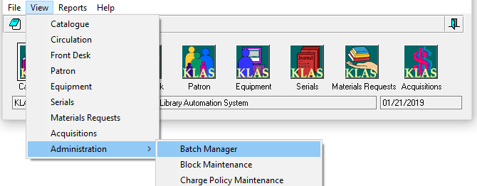
From either the KLAS Desktop or the Patron Module, select View – Administration – Batch Manager.
The Batch Manager will open in a new window.

Step Two – Create a New Job
- Use the Add button to create a new batch job.
- Use the Set Schedule button to run the job Immediately (to test and review the data) or One Time after the end of machine processing on the last day of the month (to submit to NLS).
- In the Program field, fill in: eq/rpt/machinecountbystatusp.p
Please either copy / paste the program name or double check that you have typed it correctly.
- Set the Parameters as follows:
  - Param 1: (Your Library ID)
  - Param 2: (Comma separated list of Machine IDs)
  - Param 3: (Email Address to receive the report)
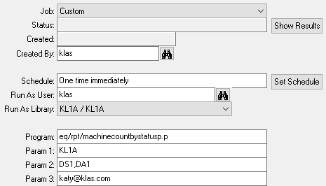
Optional: If you want to make it easier to find the job the next time you want to copy it and run it again, try this tip from Nancy! After saving the job, it will be listed in the browse as “Custom Job.” You can then modify it to change the name to something more descriptive, like “Machine Count by Status.”

Step Three – Save and Review
- Save the job. It will run as scheduled and email the report to the specified address.
- When you receive the emailed report, please review it ASAP for data issues.
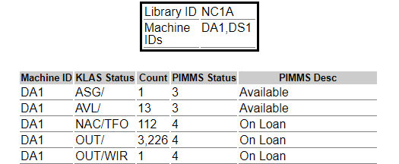
Things to watch for:
  - The number of Available machines should match what you have on hand.
  - Damaged machines should be in either PIMMS’ In Repair status or Damaged Beyond Repair.
  - EVERY line should have a PIMMS Desc. If there are any machines in a KLAS Status that does NOT have a PIMMS Desc, please correct the machines to have an accepted Status.
  - If you find a PIMMS Description that does not make sense for the KLAS Status, let us know!
For example, WDR/DMG (Withdrawn/Damaged) should have a PIMMS status of Deleted, not of Available.
  - A machine’s disposition (indicated in the KLAS Status column after each /) should match the circulation status!
For example, OUT/WIR above is a red flag—that machine should be reviewed and, most likely, the Waiting In Repair disposition should be cleared.
Every NAC – Not Available for Circulation status should have a disposition to indicate why. Watch for and correct NAC/[blank] statuses.
  - If you suspect that there were any machines added in error, let us know!
We will be able to remove them from your system without deleting them from PIMMS and thereby causing problems for the library that really has them.
If you need assistance tracking down or addressing data issues, or if you just aren’t sure,
please email the report to KLAS Customer Support along with your questions.
Because of the time-sensitive nature of this report,
contact us as soon as possible if you need help!
On behalf of both Keystone and NLS: Thank you for assisting with this process!

