Quick Preferences

Process overview
When a patron requests multiple subject preferences, the time needed to add each one individually adds up, and it is easy to miss the “exclusion” checkbox. Also, because many patrons request certain popular subjects, it can feel like you are putting in all of that work over and over… but there’s another way!
- (One time only) Create a list of commonly used Codes for your library.
- Open the Patron record to the Preference tab. Launch the Quick Preferences window from the Functions > Preferences menu or Ctrl+Alt+N.
- Select the preference type and list the desired preference codes.
  - Enter each code on a new line.
  - Create exclusions by adding an exclamation point before the code.
- When you are finished, click Save to add the preferences to the patron’s record.

Step One – Create a list of Codes
To use Quick Preferences, you will need to know the Codes for the preferences you wish to add. You can either export a list of all the subject codes used in your library’s cataloging, or you can look up the codes for the preferences you use the most (such as the subjects listed on your library’s application form) and manually add the less common preferences.
While Subjects and Series are both set up to have Codes, Authors don’t generally have Codes assigned. If you’d like to be able to add Author preferences to patron records using Quick Preferences, the person in charge of the catalogue would need to assign codes to the Author headings for that purpose. Our suggestion is to add Codes to only the top 30 authors, as a way to allow for Quick Preferences to be used without being overly burdensome.

To look up certain Codes:
- On the Patron Preferences tab, Add a new preference.
- Select the desired preference Type, then use the Find button beside the Property Value to open the Lookup window.
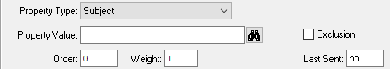
- Using the Lookup window, find up the Codes you use the most (for preferences and exclusions) and make a list with the Code and Description for each.
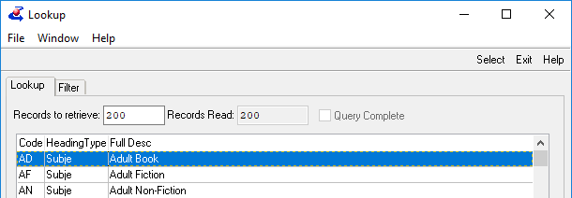

To export a full list of Codes:
- Open the Heading Maintenance window from the View > Administration menu.
- Select the desired Heading Type.
- Use the Export to Excel button.
- Increase the Maximum records field to at least 1000, and select Visible Fields.
- The list will open in Excel, where you can eliminate unneeded columns and save or print.
Now that you have a list of Codes, you will be able to add anything on your list to patron profiles very quickly.

Step Two – Launch the Quick Preferences window
- In the Patron Module, Find the patron record.
If it is a new patron, Add the record as usual and add the other necessary information.
- Open the Preference tab.
- Launch the Quick Preferences window from the Functions > Preferences menu or by pressing Ctrl+Alt+N on your keyboard.
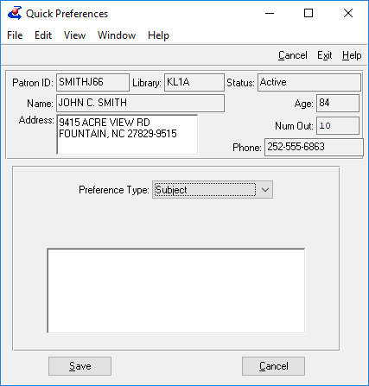

Step Three – List the preferences
- Select the Preference Type. Though Subjects are the most common preference added through Quick Preferences, you can add any type of preference so long as the Codes are in place.
- Add the desired preference Codes, typing each one on a new line.
The preferences will be added to the patron’s preference list in the order entered. If any codes are entered multiple times, the preference will only be added once, but the Weight will reflect the number of times it was listed.
- Create exclusions by adding an exclamation point before the code.
Memory tip: Think of the exclamation point as the patron saying “No!” to that code.

Example:
Patron Requests | Corresponding Codes | How the codes were entered in Quick Preferences
Romance  Historical Romance  Mystery & Detective  Historical Mystery  Cozy Mystery  Historical Fiction  Family Stories (lots!)  No Westerns!  No strong language!  No violence! | ROM  ROH  MYS  MYH  MYC  HIF  FST  WES  ST  VI | ROM  HIF  MYC  ROH  MYS  FST  FST  MYH  !WES  !ST  !VI
Note: instead of all three mystery codes being entered in a row, they’ve been scattered through the list. This will help the patron get a “good mix” of books, instead of all mysteries in one batch, and none in the next. Because Family Stories was listed twice, the patron will receive two every time it comes up in the list.

Step Four – Save the preferences
- Click the Save button to add the preferences to the patron’s record.
- If any codes were mis-typed, an error message will appear. Click OK to dismiss the error and return to the Quick Preferences list.
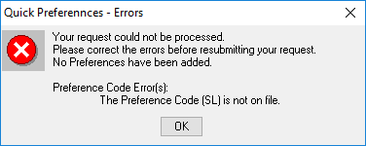
- The invalid preference code(s) will be marked in the list, so that you can easily find the error. Once you have corrected the errors, click Save again.
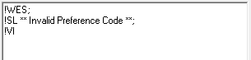
- A Success window will appear when the preferences have been added to the patron’s record. Click OK to dismiss the window.
